Pro Tour Barcelona Preview
Gary Wise

BARCELONA

In the final minutes of any sporting event, the final days of any season, it is the truly great players who find a way to win. Be it Baseball, Magic or Football, it is in the end that greatness is realized, history accomplished, destiny achieved. At PT-LA 3, Kyle Rose started the tournament 13-0, but it was the winner, Dave Price, who is still remembered for it to this day. History remembers, and is often told, by the victors.

Who will win? Who will disappoint?
With the PT season winding its way down to its end three months from now in Toronto, we reach its penultimate stop: Barcelona. The beautiful Spanish city, whose thirst for competition has been epitomized by recent Olympic glory, will play host to the world's finest as Magic's elite gather one more time to duke it out for thousands of dollars, a lot of prestige and victory. It may be time for one to etch their name in history.
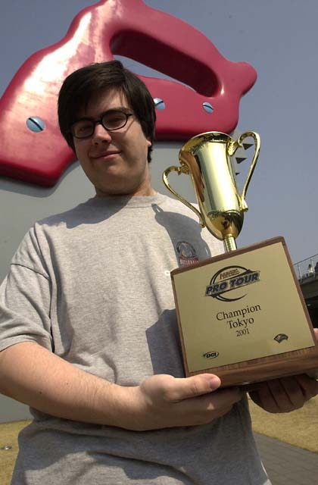
We've already seen a lot this season. We saw the financially bolstered Pro Tour joined by the Masters series in making professional Magic a legitimate way to earn a living. We've seen Kai Budde join the elite circle of two time winners, we've seen Mike Pustilnik cast the greatest Ravenous Rats of all time, we've seen Kamiel Cornelisson power his way to the top of the charts like a bullet, Zvi Mowshowitz win his first PT and Ryan Fuller become the first player to record the Pro Tour's first 14-0 finish. As with each year, our burgeoning sport is constantly resetting the bar, with new faces (and with them, new approaches and ideas) lifting the standards that in the end we must all meet to survive. Barcelona will be no different.
The questions that will be answered this weekend are numerous: Who will win? Who will disappoint? What's the best draft deck? How does one of the best Player of the Year races ever look heading into Worlds? Does Jeff Donais wear a wig? These will soon be answered (except for the latter, which will always remain an enigma), while we realize that there are many more that should have been asked, with more questions being born to the weekend's events.
Here then is a look at a few players who seem most capable of becoming the answers to those questions, allowing them their place in the sun and our history books. There are no sure things in this game, but the math seems to be in their favor. Enjoy.

PT Barcelona
With 300 some-odd competitors gathering to compete, it is Invasion Block limited which will provide the field on which they'll do battle. The process of determining which players must be watched must look at how like-formatted tournaments have resulted. Those players who have flourished in Invasion limited have shown their ability to shine under these conditions.
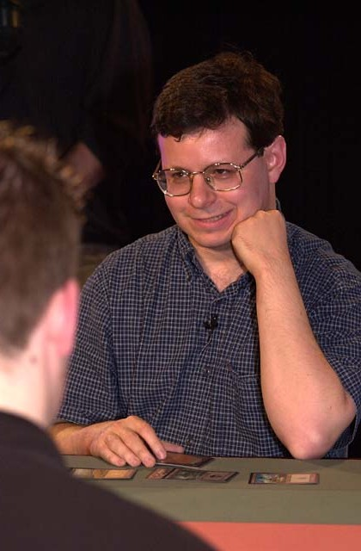
The first name that should be appraised here is Player of the Year leader Mike Pustilnik. Winner of the only Invasion Block Limited Pro Tour to be held this season, Mikey's hot streak seemed to come to an end in Tokyo where he failed to make Day 2 in his quest for a third consecutive Top 8. Whether Mike's oft-times three color approach can prove successful for the American Titan Champion remains to be seen, but his will be a path to follow in the Sideboard's coverage ahead.
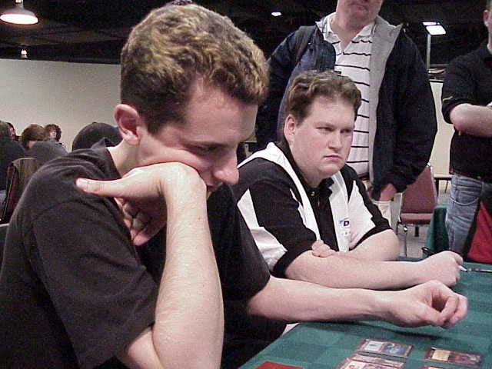
Joining Mikey P on this list is occasional team Rochester partner Matt Vienneau, whose GP achievements as of late can hardly be ignored. Yes, parts of those tournaments are Sealed instead of draft and yes their fields are usually limited to relatively local participation (with a few exceptions of course) but nonetheless, winning two American GPs the size of Dallas and Detroit and finishing fourth in another, all within the confines of one season is still impressive. One can't help to be curious though about whether Vienneau will be able to continue his success on the PT stage, where his track record since his one top 8 finish at PT Atlanta back in the 1600s has been nothing short of abysmal.
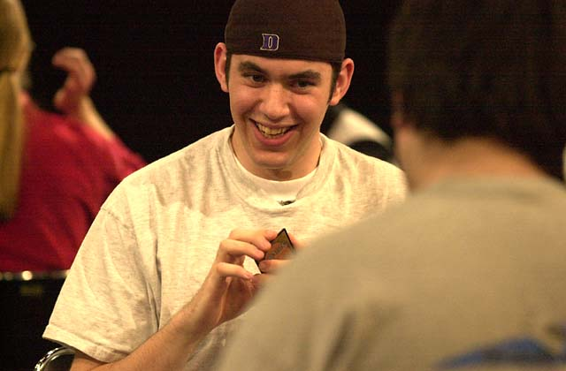
While his GP season doesn't quite match up well with Vienneau's, Chris Benafel has more than earned his keep. Don't be fooled by his success in Tokyo, Chris is first and foremost a Limited player, as he proved with his victory over 600+ others at GP Amsterdam in January. Benafel had a poor showing at PT-LA this year, but his finishes on the Boat in 1999 and at US Nats and Worlds this year have shown that the American knows what he's doing when he opens a booster pack.
Has anyone noticed that Jon Finkel has fallen out of the top ten of the Player of the Year race? Jon and the man who seems to have single-handedly train-wrecked his hopes for a second Player of the Year title, Kamiel Cornelisson, both look very solid coming into Spain. Jon has shown how good he is at drafting this format with his Top 8 in LA and his second place finish in the Chicago Masters, while Kamiel's one Limited Pro Tour, a second place finish in LA, seems to suggest that he'll be ready to take on all comers over the weekend.
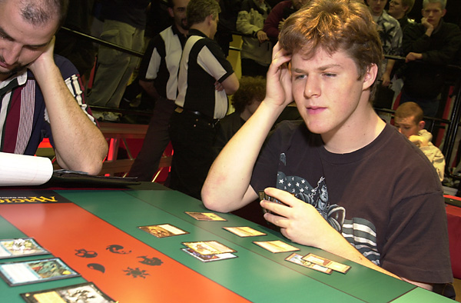
Last but not least, Ben Rubin obviously knows what he's doing with this format. While the four-time Top 8 finisher has a poor PTLA, this is outweighed by his victory in Chicago Masters, which used a format only one booster removed from this one. If Ben has prepared for Planeshift and gotten to know the cards, there's no reason to believe he won't have a strong tournament in Barcelona.
One last note: Watch for the Netdraft factor. In the past, with the exception of PTLA 2000, those Pro Tour Players who have trained using Netdraft have performed very well, with their statistical averages far exceeding those who haven't. Well known NetDrafters include Kai Budde, Zvi Mowshowitz, Warren Marsh, Dan O'Mahoney-Schwartz, Ben Ronaldson, Eric Froelich, Brock Parker, Menno Dolstra and a host of others (I've been known to Netdraft from time to time). Look for a solid showing from these players.

Barcelona Masters
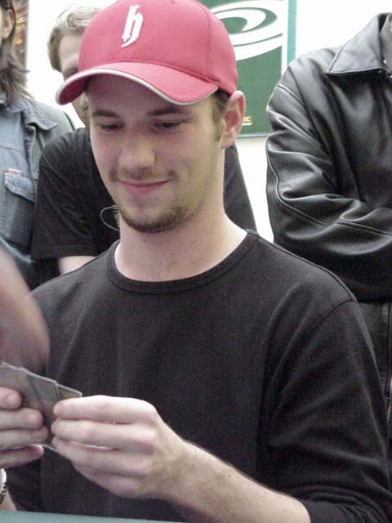
Well, with the streak he's on, one can't help but look to Ryan Fuller on this one. With a 14-0 swiss in Tokyo and his recent win in Moscow, one can't help but think that he really knows the format. Obviously playing the best Magic of his career, the Canadian living in Amsterdam has moved himself to within striking distance of the PotY race lead, so look for him to make a strong push. Ryan has worked with Chris Benafel, Noah Boeken and Kamiel Cornelisson for the event.
Obviously, Zvi Mowshowitz also has to be considered a favorite. Zvi 'solved' the environment in Tokyo, sweeping the final en route to his first PT victory in three Top 8 tries. Whether he'll play the Solution again with metagame shifts created by Moscow is anyone's guess, but you can be sure he'll have put his work in, adjusting accordingly for whatever changes he expects to see in Spain, and with Scott Johns and Kai Budde amongst those who he's working with, he should do very solidly.
Speaking of Mr. Budde, one shouldn't forget the man just won his second Pro Tour and it was a Constructed one. Kai has been hard at work perfecting his draft style every day online and with the aforementioned Mowshowitz-Johns team up on his side, he'll be ready with a strong deck in hand.

As for the builders of Kai and Zvi's decks, Warren Marsh, who came second at PT-NY last year needs a strong showing, with those 24 points he got in the Big Apple poised to fall off his record, just as he will fall off the masters series without a strong showing in Spain. Look for Warren, working with teammate Ben Ronaldson and other deck-building bigwig Brian Kibler, to come up with something interesting for the tournament, with Warren's deck being played by other competitors as well.
As for the gateway, this one is anyone's to be had. Mattias Jordstedt started Moscow 8-0 before a rocky finish, so he may be poised for another run, while Frenchman Franck Canu seems to be the closest thing to a gateway specialist, but your guess is as good as mine as to how anyone in the running will do. To find out, stay tuned to the Sideboard coverage over the weekend.

